Container shipping fuel prices remain elevated as supply fears ease

Stuart Chirls, Wednesday, September 16, 2026
Original Article: https://www.freightwaves.com/news/container-shipping-fuel-prices-remain-elevated-as-supply-fears-ease
Articles Reproduced by Permission of FreightWaves

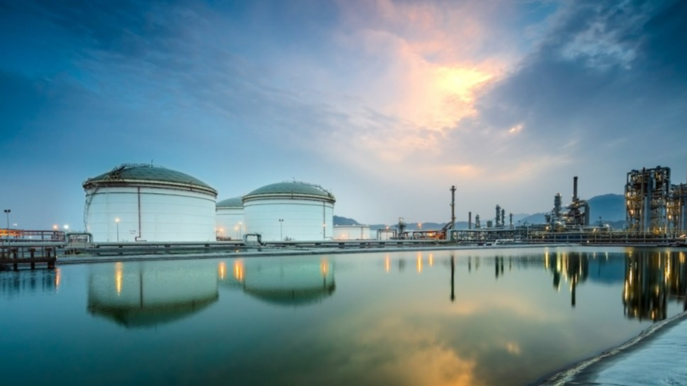
Vitol's bunkering facility at Fujairah, UAE. (Photo: Vitol/ FreightWaves)

Bunker prices soared 74% in just three months earlier this year

Bunker fuel prices for ships remain at historically elevated levels, keeping pressure on vessel operating costs even as the marine-fuel supply squeeze that followed disruption around the Strait of Hormuz has eased at major fueling hubs.

In Singapore, the world’s largest bunkering center, very-low-sulphur fuel oil, or VLSFO, was assessed at about $908 per metric ton this week, while marine gasoil (MGO) stood at $1,448 per ton and high-sulphur fuel oil at roughly $770 per ton, according to analyst Ship & Bunker.

At Rotterdam, Europe’s busiest port, VLSFO was about $731 per ton, compared with $804 per ton in Houston and $1,005 per ton in Fujairah, United Arab Emirates.

The premium at Fujairah, the Middle East’s principal bunker hub, shows the continuing impact of constrained traffic and supply-chain disruption in and around the Strait of Hormuz. Bunkering activity at Fujairah has recovered to about 40% of its prewar level, according to industry comments reported from the Asia Pacific Petroleum Conference, but remains well below normal.

Costs still far above January
Singapore VLSFO climbed from $433.50 per metric ton on Jan. 1 to $878.50 per ton by Sept. 11, an increase of more than 100%. That was more than 60% above pre-conflict levels, Reuters reported, even after retreating from the record highs reached during the most acute supply disruption.

Fears over renewed violence in the Red Sea and Strait of Hormuz helped push Brent crude oil above $107 per barrel on Sept. 14. The cost of vessel detours, disruption to tanker traffic and constrained access to Gulf-origin crude and fuel-oil feedstocks have all tightened the market for marine fuel.

That’s also led refiners to concentrate on higher-margin gasoline and diesel, threatening availability of blending components required to produce specification-compliant VLSFO, particularly in Asia, which depends heavily on Gulf supply flows.

Supply conditions improve
Industry executives say the outright shortage of bunkers seen in March and April has abated, and that operators no longer faced problems sourcing marine fuel and loading it aboard vessels at major hubs.

Market observers estimate that 10 to 15 commodity vessels a day are still using the Omani corridor on the southern side of Hormuz, though transits fell to single digits during the past weekend, according to preliminary ship-tracking data cited by Reuters.

The result is a market that has shifted from an availability crisis to a price and volatility problem: shipowners can generally secure fuel, but at a substantially higher cost and with less certainty about regional price differentials.

The increase in bunker costs will raise pressure on container lines, tanker owners, bulk carriers and ship managers, although the extent of pass-through to customers will vary. On contracted container business, carriers look to cost recovery through negotiated bunker adjustment factors or emergency fuel surcharges. On spot trades, recovery depends on vessel supply, demand, port congestion, rerouting and carrier pricing.

Fleet age matters, too. The St. Louis Fed estimated that the early-2026 fuel shock increased fuel cost on a typical China–U.S. West Coast voyage from $155 to $269 per 20-foot container for a newer ship, and from $360 to $626 per container for an older vessel.

Outlook remains uncertain
Ship & Bunker last week raised its expected average price for a 20-port VLSFO benchmark to $758 per ton in the fourth quarter, from a prior estimate of $646 per ton. It projected Singapore VLSFO would average $720 per ton in the fourth quarter, although current outright prices are materially higher than that forecast level.

Why it matters: Carriers can attempt to pass higher fuel costs along through bunker adjustment factors, emergency fuel surcharges, or higher spot freight rates. That makes landed costs less predictable for importers and exporters, particularly in the trans-Pacific, Asia–Europe and Middle East trades.

